Roshinie Persaud

Gemma Bruce

Oleksandr Litus

Dr. Susan Freeman

GE 1501

October 25, 2018

**Purpose:**

To test the the accuracy and validation of the sensor reading with the actual distance data of the robot.

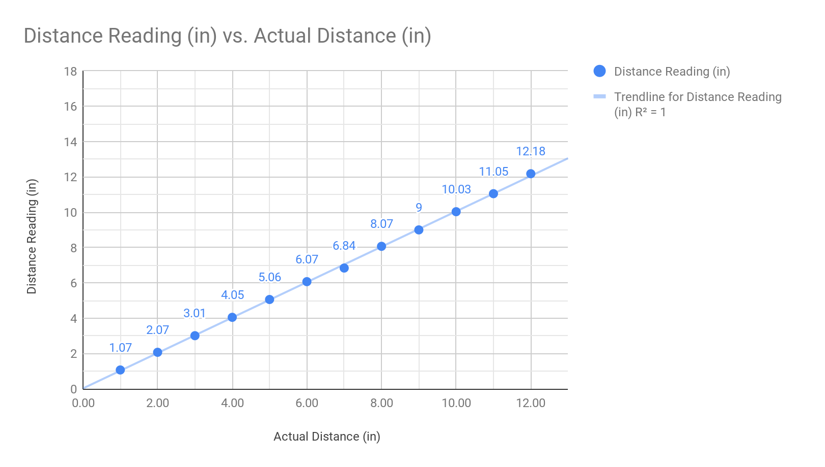

**Relationship Between the Distance and the Readings:**

There is a positive linear correlation between the actual distance and the distance readings. We can tell that it is a good fit because of this correlation and the R2 is equal to 1.

**What Does This Tell You About the Sensor and Information:**

This displays that there is an accuracy and precision of the readings and the actual distance and that the robot will read and accurate distance when it comes to contact with a physical component.